Courses Roadmap

Software Development Plan

Version 2.0

Revision History

|  |  |  |  |
| --- | --- | --- | --- |
| **Date** | **Version** | **Description** | **Author** |
| 26/10/2021 | 1.0 | First Project Plan | Ngo Huy Anh |
| 20/11/2021 | 1.1 | Add Risk Managenemt | Nguyen Duc Nam |
| 25/11/2021 | 1.2 | Update Gantt Chart | Ngo Huy Anh |
| 26/11/2021 | 2.0 | Update Project plan | Ngo Huy Anh |

Table of Contents

1. Introduction 4

1.1 Purpose 4

1.2 Scope 4

2. Project Overview 4

2.1 Project Purpose, Scope, and Objectives 4

2.2 Assumptions and Constraints 4

2.3 Project Deliverables 4

3. Project Organization 4

3.1 Organizational Structure 4

3.2 Roles and Responsibilities 5

4. Management Process 6

4.1 Project Estimates 6

4.2 Project Plan 6

4.2.1 Phase and Iteration Plan 6

4.2.2 Releases 15

4.2.3 Project Schedule 16

4.3 Project Monitoring and Control 19

4.3.1 Reporting 19

4.3.2 Risk Management 19

4.3.3 Configuration Management 20

Software Development Plan

# 

# Introduction

The introduction of the Software Development Plan provides an overview of the entire project. It includes the purpose, scope, definitions, acronyms, abbreviations, references, and overview of this Software Development Plan.

## Purpose

## Scope

# Project Overview

## Project Purpose, Scope, and Objectives

“Courses Roadmap” is a website that gives readers an overview of the landscape of what they should study in each area and leads them through which courses to take if they are unsure what to learn next. Aside from that, if all of the courses are completed, readers may also provide course evaluations and recommend other courses. The roadmap is limited to the field of information technology.

Almost all existing roadmaps just outline what to learn rather than specific study resources and where to study. This makes learning more difficult for newbies or people without an IT background, **so “Courses Roadmap” will make studying easier for them.**

## Assumptions and Constraints

* Project has a fixed schedule of 12 weeks
* Zero-budget project
* Project has 5 people, there will be no more people added during the project

## Project Deliverables

Deliverables for each project phase are identified in the Development Case. Deliverables are delivered towards the end of the Iteration, as specified in section ***4.2.3 Project Schedule***

# Project Organization

## Organizational Structure

## 

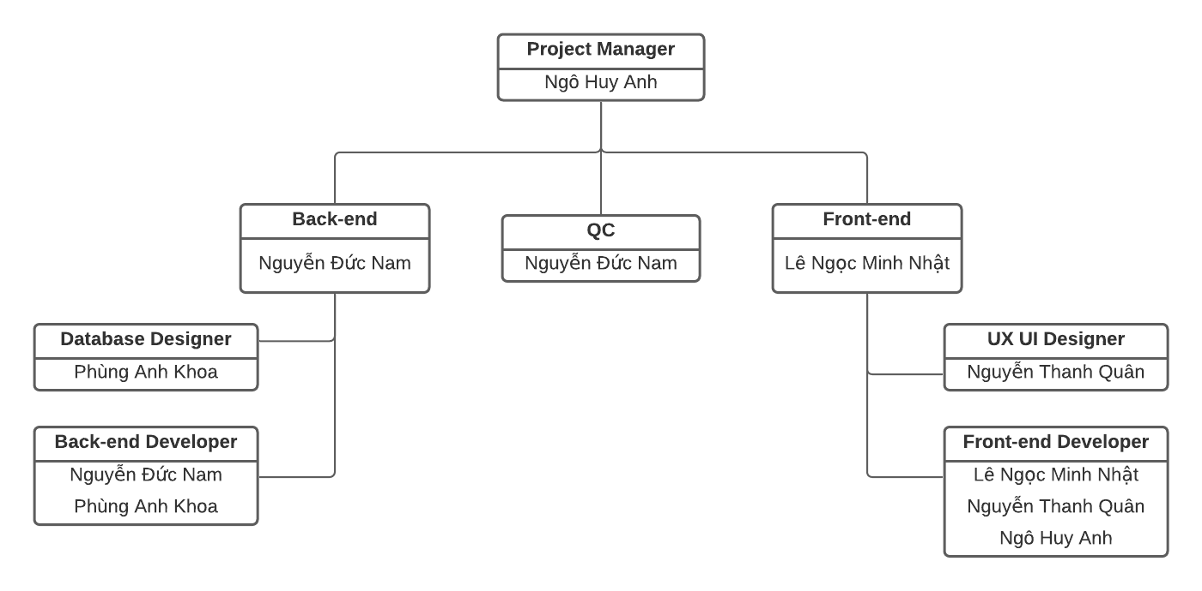

## Roles and Responsibilities

|  |  |
| --- | --- |
| **Person** | **Role** |
| Ngô Huy Anh  Nguyễn Đức Nam  Phùng Anh Khoa  Lê Ngọc Minh Nhật  Nguyễn Thanh Quân | Project Manager + Support Front-end team  Back-end Developer + QC  Back-end Developer + Database Designer  Front-end Developer + Tester  UX UI Designer + Front-end Developer |

# Management Process

## Project Estimates

* Zero-budget project
* Project has a fixed schedule of 12 weeks
* Project has 5 people, there will be no more people added during the project
* Project start at 11/10/2021
* Project end at 25/12/2021

## Project Plan

### **Phase and Iteration Plan**

Our project has 3 phases: Inception, Elaboration and Construction:

|  |  |  |  |  |
| --- | --- | --- | --- | --- |
| Phase | Sprint | Time estimate | Start date | End date |
| Inception | 1 | 1 week | 16/10/2021 | 24/10/2021 |
| Elaboration | 2, 3 | 2 weeks | 31/10/2021 | 14/11/2021 |
| Construction | 4, 5 | 2 weeks | 27/11/2021 | 27/12/2021 |

In this section, the project plan is represented as a table and gantt chart (inside TeamGantt). The following tables are the project plan for each sprint (2 week/sprint). Each type of tasks in the plan has different background color as table below:

|  |  |
| --- | --- |
| **Color** | **Type of tasks** |
| Yellow | **Meeting** |
| Green | **Document** |
| Pink | **Self Learning** |
| Blue | **Front-end task** |
| Red | **Back-end task** |
| Purple | **Testing** |

***Sprint 0***

|  |  |  |  |  |
| --- | --- | --- | --- | --- |
| ***Start*** | ***End*** | ***Task*** | ***Staff*** | ***Output*** |
| *14/10/2021* | *14/10/2021* | *Sprint planning meeting* | *All* | *Group registration and set roles*  *Tools setup*  *Plan tasks for next sprint* |
| *11/10/2021* | *16/10/2021* | *Creating Google Drive & Document* | *Huy Anh* | *Google Drive & Document* |
| *11/10/2021* | *16/10/2021* | *Discuss SE’s project* | *All* | *1. Choose create web*  *2. Have the list of features* |
| *11/10/2021* | *16/10/2021* | *Writing project proposal* | *Huy Anh* | *Complete project proposal* |

***Sprint 1***

|  |  |  |  |  |
| --- | --- | --- | --- | --- |
| ***Start*** | ***End*** | ***Task*** | ***Staff*** | ***Output*** |
| *16/10/2021* | *23/10/2021* | *Learn HTML CSS* | *All* | *Complete basic HTML, CSS* |
| *16/10/2021* | *30/10/2021* | *Learn Firebase* | *Duc Nam*  *Anh Khoa* | *Complete basic of Firebase* |
| *16/10/2021* | *23/10/2021* | *Learn about Scrum Agile* | *Huy Anh* | *Have knowledge of Scrum Agile* |
| *16/10/2021* | *30/10/2021* | *Learn ReactJS* | *Minh Nhat*  *Thanh Quan*  *Huy Anh*  *Duc Nam* | *Complete basic of Reactjs* |
| *16/10/2021* | *23/10/2021* | *Learn MockPlus* | *Thanh Quan* | *Complete basic of MockPlus* |
| *16/10/2021* | *23/10/2021* | *Learn make Gantt Chart* | *Huy Anh* | *Have knowledge of Gantt Chart* |
| *22/10/2021* | *29/10/2021* | *Sprint planning meeting* | *Huy Anh* | *Sprint planning schedule* |
| *22/10/2021* | *22/10/2021* | *Weekly report 1* | *Huy Anh* | *Weekly report of week 1* |
| *29/10/2021* | *29/10/2021* | *Weekly report 2* | *Huy Anh* | *Weekly report of week 2*  *Done PA1* |
| *16/10/2021* | *30/10/2021* | *Project plan* | *Huy Anh* | *Complete Project plan* |
| *16/10/2021* | *30/10/2021* | *Vision document* | *Huy Anh* | *Complete Vision document* |
| *16/10/2021* | *30/10/2021* | *Design wireframe for Main page* | *Thanh Quan*  *Minh Nhat* | *Complete Wireframes of web* |
| *22/10/2021* | *22/10/2021* | *Give feedbacks for wireframe* | *All* | *Update wireframes* |
| *22/10/2021* | *30/10/2021* | *Find some template for Front-end* | *All* | *Have a list of templates* |
| *24/10/2021* | *30/10/2021* | *Fix bug from feedback of PA0* | *Thanh Quan*  *Minh Nhat* | *Update project* |
| *16/10/2021* | *30/10/2021* | *Design DB Schema* | *Anh Khoa* | *ER model* |
| *16/10/2021* | *30/10/2021* | *Research Firebase* | *Anh Khoa* | *Authentication, Authorization* |
| *24/10/2021* | *30/10/2021* | *Fix bug from feedback of PA0* | *Anh Khoa*  *Duc Nam* | *Update project* |

***Sprint 2***

|  |  |  |  |  |
| --- | --- | --- | --- | --- |
| ***Start*** | ***End*** | ***Task*** | ***Staff*** | ***Output*** |
| *31/10/2021* | *13/11/2021* | *Learn ReactJS* | *All* | *Complete ReactJS* |
| *31/10/2021* | *06/11/2021* | *Weekly report 1* | *Huy Anh* | *Weekly report of week 1* |
| *06/11/2021* | *13/11/2021* | *Weekly report 2* | *Huy Anh* | *Weekly report of week 2* |
| *31/10/2021* | *13/11/2021* | *Revised Project Plan & Detail Vision document* | *Huy Anh* | *Complete Revised Project Plan & Detail Vision document* |
| *31/10/2021* | *13/11/2021* | *Use-case model & specification* | *Huy Anh* | *Complete Use-case model & specification* |
| *31/10/2021* | *13/11/2021* | *Coding Login form, About us, User profile* | *Thanh Quan*  *Minh Nhat*  *Huy Anh* | *Complete Login form, About us* |
| *31/10/2021* | *13/11/2021* | *Fix bugs from feedback of PA1* | *Thanh Quan*  *Minh Nhat*  *Huy Anh* | *Fixed bugs* |
| *31/10/2021* | *13/11/2021* | *Find set color & typography for web* | *Thanh Quan*  *Minh Nhat*  *Huy Anh* | *Have set color & typography for web* |
| *31/10/2021* | *13/11/2021* | *Research SPA* | *All* | *Have knowledge of SPA* |
| *31/10/2021* | *13/11/2021* | *Upload information of user to Firebase* | *Duc Nam*  *Anh Khoa* | *Complete Upload information of user to Firebase* |
| *31/10/2021* | *13/11/2021* | *Authentication* | *Duc Nam*  *Anh Khoa* | *Complete Authentication* |
| *31/10/2021* | *13/11/2021* | *Coding “Light - dark mode”, “Log in - Log out” features, Scroll back to top Button* | *Duc Nam*  *Anh Khoa* | *Complete “Light - dark mode”, “Log in - Log out” features, Scroll back to top Button* |
| *31/10/2021* | *13/11/2021* | *Fix bugs from feedback of PA1* | *Duc Nam*  *Anh Khoa* | *Fixed bugs* |

***Sprint 3***

|  |  |  |  |  |
| --- | --- | --- | --- | --- |
| ***Start*** | ***End*** | ***Task*** | ***Staff*** | ***Output*** |
| *14/11/2021* | *20/11/2021* | *Weekly report 1* | *Huy Anh* | *Weekly report of week 1* |
| *20/11/2021* | *27/11/2021* | *Weekly report 2* | *Huy Anh* | *Weekly report of week 2* |
| *14/11/2021* | *27/11/2021* | *Update Use-case model & specification* | *Huy Anh* | *Complete Update Use-case model & specification* |
| *14/11/2021* | *27/11/2021* | *Define Software Architecture* | *Huy Anh* | *Complete Define Software Architecture* |
| *14/11/2021* | *27/11/2021* | *Class Diagram* | *Huy Anh* | *Complete Class Diagram* |
| *14/11/2021* | *27/11/2021* | *Coding Sidebar menu, page Home, Edit profile, Course, Admin page* | *Thanh Quan*  *Minh Nhat*  *Huy Anh*  *Duc Nam* | *Complete Sidebar menu, page Home, Edit profile, Course, Admin page.* |
| *14/11/2021* | *27/11/2021* | *Fix bugs from feedback of PA2* | *Thanh Quan*  *Minh Nhat*  *Huy Anh* | *Fixed bugs* |
| *14/11/2021* | *27/11/2021* | *Fix bugs from feedback of PA2* | *Duc Nam*  *Anh Khoa* | *Fixed bugs* |
| *14/11/2021* | *27/11/2021* | *Coding “Add new Courses”, “Change password”, “Forgot password”, “Sign up with Google Gmail” features* | *Duc Nam*  *Anh Khoa* | *Complete “Add new Courses”, “Change password”, “Forgot password”, “Sign up with Google Gmail” features* |
| *14/11/2021* | *27/11/2021* | *Research deploy Firebase Server* | *Duc Nam*  *Anh Khoa* | *Have knowledge of deploy Firebase Server* |

***Sprint 4***

|  |  |  |  |  |
| --- | --- | --- | --- | --- |
|  |  |  |  |  |
| *27/11/2021* | *04/12/2021* | *Weekly report 1* | *Huy Anh* | *Weekly report of week 1* |
| *04/12/2021* | *11/12/2021* | *Weekly report 2* | *Huy Anh* | *Weekly report of week 2* |
| *27/11/2021* | *11/12/2021* | *Revise SAD* | *Huy Anh* | *Complete Revise SAD* |
| *27/11/2021* | *11/12/2021* | *UI Prototype* | *Huy Anh* | *Complete UI Prototype* |
| *27/11/2021* | *11/12/2021* | *Coding page Web, Roadmap, Story* | *Thanh Quan*  *Minh Nhat*  *Huy Anh* | *Complete Web, Roadmap, Story.* |
| *27/11/2021* | *11/12/2021* | *Fix bugs from feedback of PA3* | *Thanh Quan*  *Minh Nhat*  *Huy Anh* | *Fixed bugs* |
| *27/11/2021* | *11/12/2021* | *Deploy Firebase server* | *Duc Nam*  *Anh Khoa* | *Complete Deploy Firebase server* |
| *27/11/2021* | *11/12/2021* | *Coding “Share one page on Facebook”, “Search topic”, “Communicate with Admin”, “Set roles” features* | *Duc Nam*  *Anh Khoa* | *Complete “Share one page on Facebook”, “Search topic”, “Communicate with Admin”, “Set roles” features* |
| *27/11/2021* | *11/12/2021* | *Fix bugs from feedback of PA3* | *Duc Nam*  *Anh Khoa* | *Fixed bug* |

***Sprint 5***

|  |  |  |  |  |
| --- | --- | --- | --- | --- |
| ***Start*** | ***End*** | ***Task*** | ***Staff*** | ***Output*** |
| *12/12/2021* | *25/12/2021* | *Test plan and test case* | *Minh Nhat*  *Thanh Quan*  *Huy Anh* | *Test plan and test case* |
| *12/12/2021* | *25/12/2021* | *Automated testing* | *Minh Nhat*  *Thanh Quan*  *Huy Anh* | *Automated testing* |
| *12/12/2021* | *19/12/2021* | *Weekly report 1* | *Huy Anh* | *Weekly report 1* |
| *19/12/2021* | *25/12/2021* | *Weekly report 2* | *Huy Anh* | *Weekly report 2*  *Done PA5* |
| *12/12/2021* | *25/12/2021* | *Test and fix application bugs* | *Duc Nam*  *Anh Khoa* | *Fix and update application* |
| *12/12/2021* | *25/12/2021* | *Test and fix server bugs* | *Duc Nam*  *Anh Khoa* | *Fix and update server, sheet* |

***Sprint 6***

|  |  |  |  |  |
| --- | --- | --- | --- | --- |
| ***Start*** | ***End*** | ***Task*** | ***Staff*** | ***Output*** |
| *03/01/2022* | *08/01/2022* | *Project presentation* | *All* | *Final presentation of team in front of teachers* |
| *27/12/2021* | *03/01/2022* | *Final submission* | *Huy Anh* | *Done PA6* |

### **Releases**

There will be 6 or more version for each iteration:

* Version 1.0: Demo the product after it is already completed.
* Version 1.1: Demo the product after Sprint 1
* Version 1.2: Demo the product after Sprint 2
* Version 1.3: Demo the product after Sprint 3
* Version 1.4: Demo the product after Sprint 4
* Version 1.5: Demo the product after Sprint 5
* Version 1.6: The product after being tested.

### **Project Schedule**

The Gantt Chart is created on TeamGantt to show the milestone and project schedule.

The gantt chart is included in the same folder of this document to show the milestone and project schedule.

**Sprint 1:**

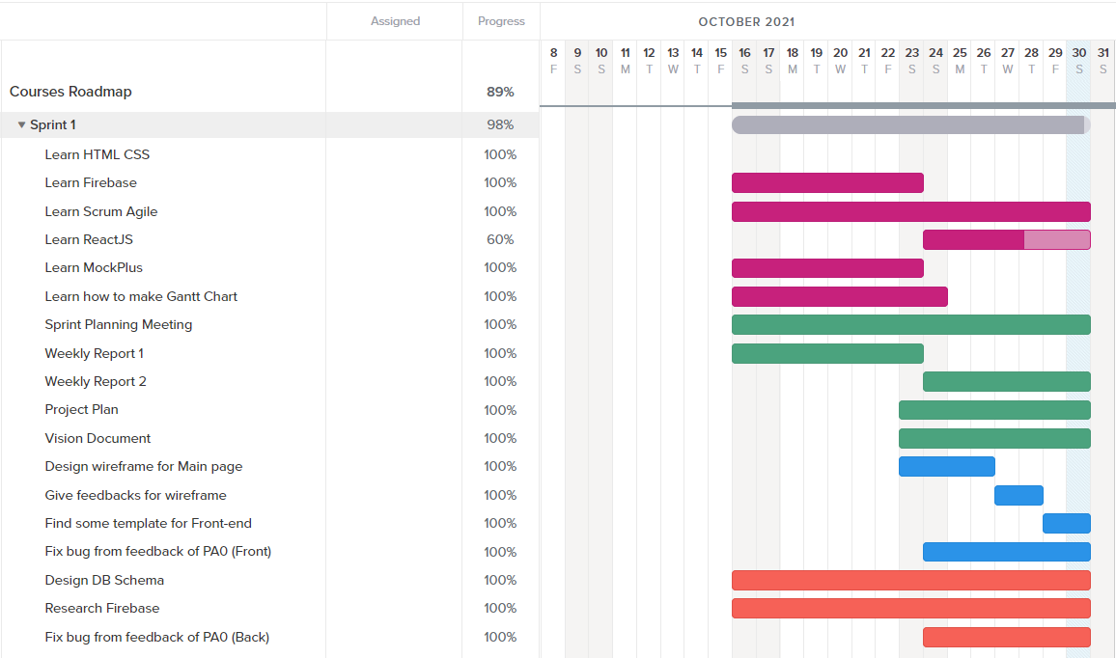

**Sprint 2:**

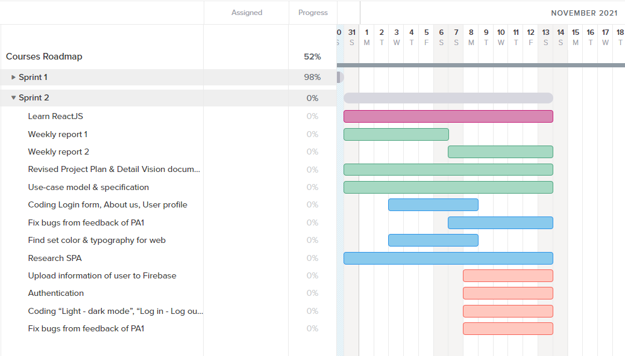

**Sprint 3:**

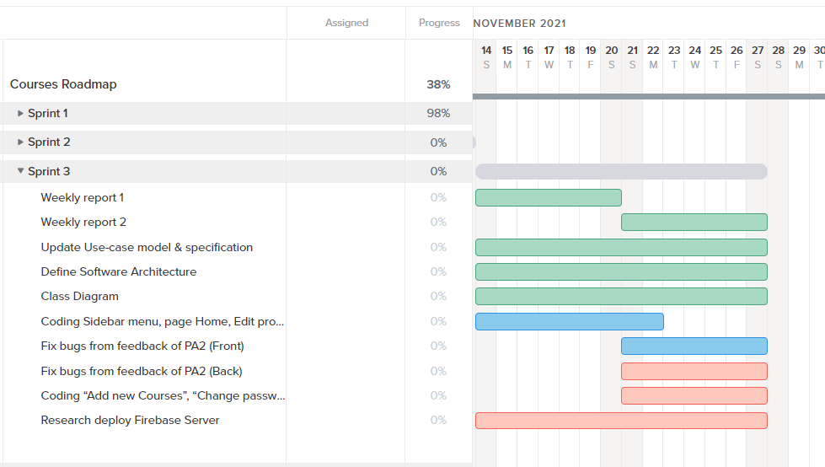

**Sprint 4:**

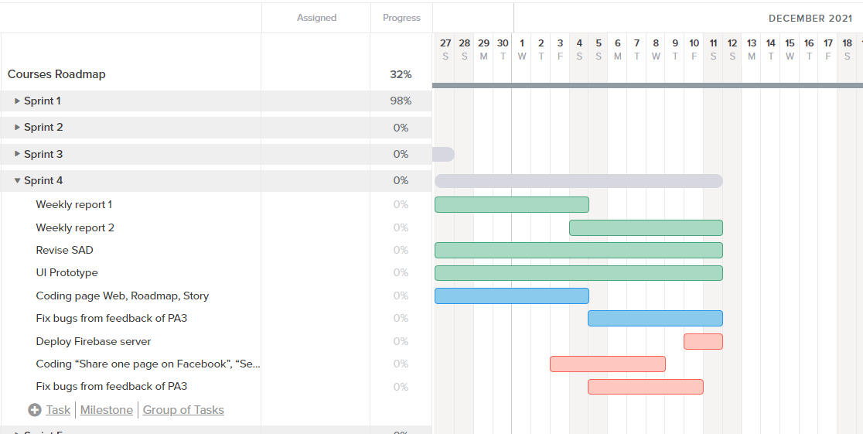

**Sprint 5:**

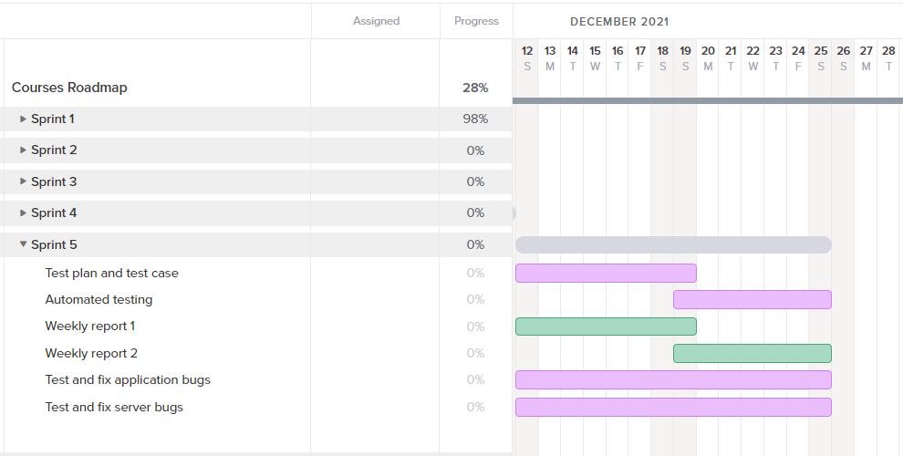

**Sprint 6:**

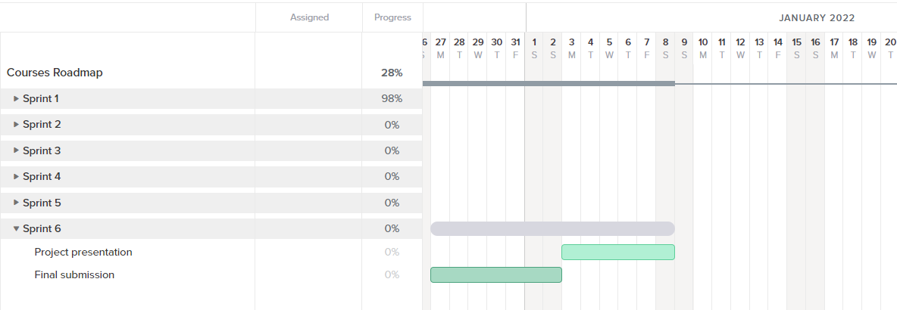

## Project Monitoring and Control

This section is to provide the monitoring of:

* Requirements managements
* Reporting and measurement
* Risk management
* Configuration Management

### **Reporting**

The development team will have a meeting held on Google Meeting every Friday morning from 9:00 AM to 10:30 AM. If the Project Manager finds that something went wrong or needs to be discussed at that time, the team will arrange the time properly and have a Hot Meeting.

All the tasks and task reviews will be submitted to Trello. Aside from that, members can also talk about it on Slack.

### **Risk Management**

**Risk type 1:** We could solve

|  |  |  |
| --- | --- | --- |
| Risk Level | Risk Description | Solve |
| High | Members do not have enough skill in web development | Learn HTML, CSS, Javascript, Bootstrap, React.js from some platform like Website or Youtube |
| Medium | Current knowledge is insufficient for the project | Learn from docs or reference on Google to solve |
| Medium | Firebase's free service is no longer available | Create another Project or Account on Firebase instead |

**Risk type 2:** We could not solve, we need 3rd party service for help

|  |  |  |
| --- | --- | --- |
| Risk Level | Risk Description | Solve |
| High | Database can not run 24/7 and available to all members. | Use Firebase Realtime Database |
| High | Storage can not run 24/7 and available to all members. | Use Firebase Storage |

**Risk type 3**: We accept the risk

**Bad internet connection**: because our Server is Firebase platform, the performance **c**ompletely dependent on internet connection.

### **Configuration Management**

The Development team may use tools for storing and sharing code and files, such as:

* Git & Github is used for managing **source code** and **related files**.
* Google Drive is used for storing and sharing **documents** and **submissions**.
* Trello is used for storing **tasks** and **task reviews**
* Slack is used for discussing **tasks** or **anything** that **makes team** members **confused**.